|  |
| --- |
| **assorted colored spiritual crystals** |

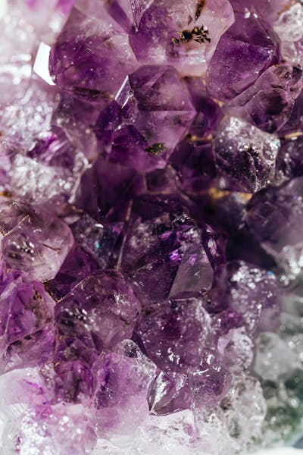

**Amethyst (Purple)**: Promotes spiritual growth, calmness, and emotional balance, aligning with the **crown** and **third eye chakras**.

**Rose Quartz (Pink)**: Known for love, compassion, and emotional healing, it opens the **heart chakra**.